10 Case Studies — Complete Report

Contents

1 .Progressive Electricity Billing

2. Employee Payroll and Deduction Analysis

3. ATM Transaction Sequence Simulation

4. Warehouse Inventory Reconciliation

5. Smart Parking Fee Management

6. Password Policy Validation Engine

7. String-Based Examination Answer Evaluation

8. ATM Menu-Driven Banking Simulation

9. Food Waste Monitoring System

10. Library Borrowing and Fine

Progressive Electricity Billing

1.Problem Statement

Write a Python program to calculate a household electricity bill using progressive consumption slabs.

Objectives

To calculate the bill by applying different rates to different ranges of electricity units.

3. Assumptions

First 100 units cost Rs.2 per unit.
Units 101–200 cost Rs.3 per unit.
Units above 200 cost Rs.5 per unit.
No fixed charges, surcharge, or rebate is included.

4. Algorithm

1. Start the program.
2. Read the number of units consumed.
3. If units are at most 100, multiply all units by Rs.2.
4. If units are 101–200, charge the first 100 units at Rs.2 and the remaining units at Rs.3.
5. If units exceed 200, charge the first 100 at Rs.2, the next 100 at Rs.3, and the remaining units at Rs.5.
6. Display the bill and stop.

5. Flowchart

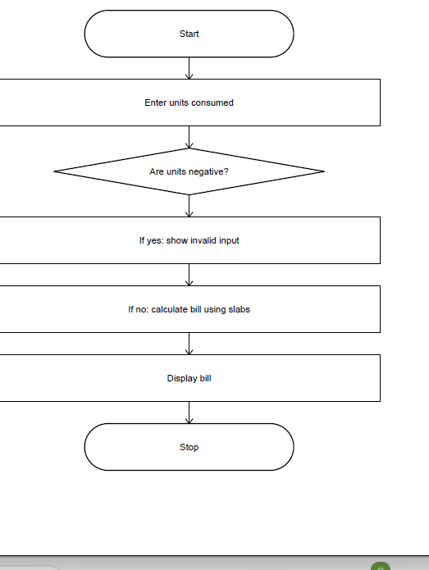

6. Pseudo code

START
INPUT units
IF units < 0
PRINT invalid units
ELSE IF units <= 100
bill = units * 2
ELSE IF units <= 200
bill = 100 * 2 + (units - 100) * 3
ELSE
bill = 100 * 2 + 100 * 3 + (units - 200) * 5
END IF
PRINT bill
STOP

7. Python Source Code

units = int(input("Enter electricity units: "))
if units < 0:
print("Invalid units")
elif units <= 100:
bill = units * 2
elif units <= 200:
bill = 100 * 2 + (units - 100) * 3
else:
bill = 100 * 2 + 100 * 3 + (units - 200) * 5
if units >= 0:
print("Electricity Bill =", bill)

8. Test Cases and Outputs

Units
Expected bill
50
Rs.100
150
Rs.350
250
Rs.850
Sample Output Screenshot (console-style panel)
Enter electricity units: 150
Electricity Bill = 350

Screenshot of output

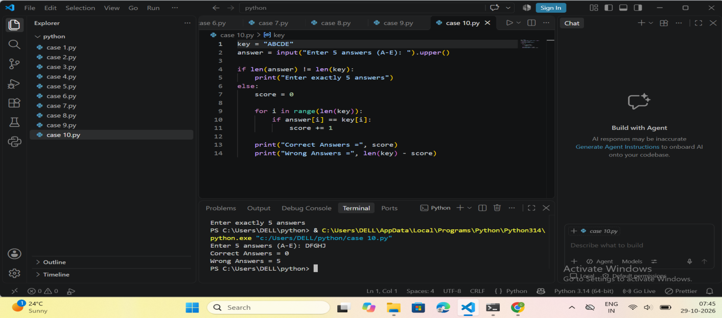

9. Conclusion
The program uses if-elif-else statements and arithmetic to calculate an electricity bill using progressive slabs.

2. Employee Payroll and Deduction Analysis

Problem Statement

Calculate an employee's gross salary and net salary after allowances and deductions.

2. Objectives
To prepare a simple salary statement using arithmetic operations.

3. Assumptions
Allowance is 20% of basic salary.
Deduction is 10% of basic salary.
Overtime and incentives are not included in this beginner version.

4. Algorithm
1. Start.
2. Read basic salary.
3. Calculate allowance as 20% of basic salary.
4. Calculate deduction as 10% of basic salary.
5. Calculate gross salary and net salary.
6. Display the salary details and stop.

5. Flowchart
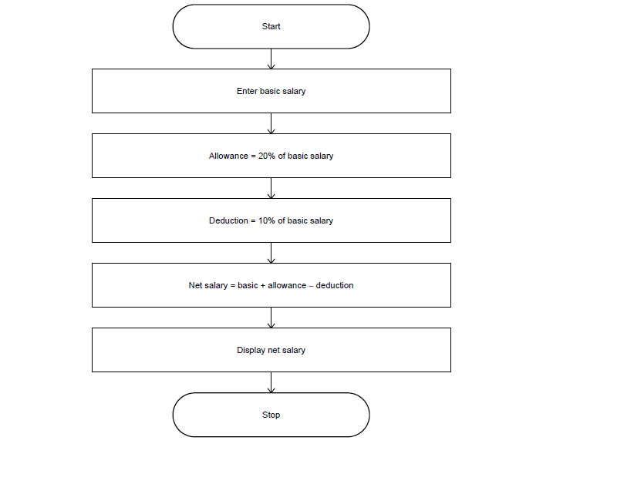

6. Pseudocode
START
INPUT basic salary
allowance = basic salary * 0.20
deduction = basic salary * 0.10
gross = basic salary + allowance
net = gross - deduction
PRINT allowance, deduction, gross, net
STOP

7. Python Source Code
basic = float(input("Enter basic salary: "))
if basic < 0:
print("Invalid salary")
else:
allowance = basic * 0.20
deduction = basic * 0.10
gross = basic + allowance
net = gross - deduction
print("Basic Salary =", basic)
print("Allowance =", allowance)
print("Deduction =", deduction)
print("Gross Salary =", gross)
print("Net Salary =", net)

8. Test Cases and Outputs
Basic salary
Expected net salary
10000
Rs.11000
20000
Rs.22000
30000
Rs.33000
Sample Output Screenshot (console-style panel)
Enter basic salary: 20000
Basic Salary = 20000.0
Allowance = 4000.0
Deduction = 2000.0
Gross Salary = 24000.0
Net Salary = 22000.0

Screenshot of output

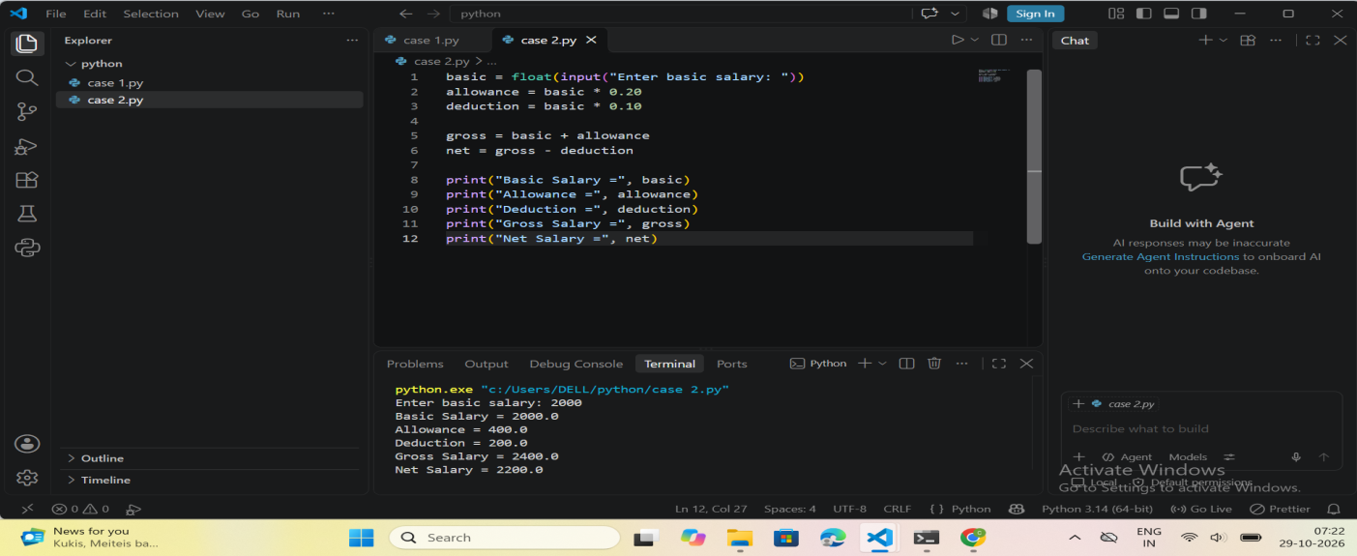

9. Conclusion
The program calculates allowance, deduction, gross salary, and net salary using simple formulas

3. ATM Transaction Sequence Simulation

1. Problem Statement
Simulate a sequence of deposits and withdrawals while maintaining a bank balance.

2. Objectives
To practise loops, conditions, and balance updates for multiple transactions.

3. Assumptions
The opening balance is Rs.1,000.
The user can deposit, withdraw, check balance, or exit.
A withdrawal is allowed only if the amount is positive and does not exceed the balance.

4. Algorithm
1. Start with a balance of Rs.1,000.
2. Display the transaction menu.
3. Read the user's choice.
4. Perform deposit, withdrawal, or balance check.
5. Reject invalid amounts or insufficient balance.
6. Repeat until Exit is selected.

5. Flowchart
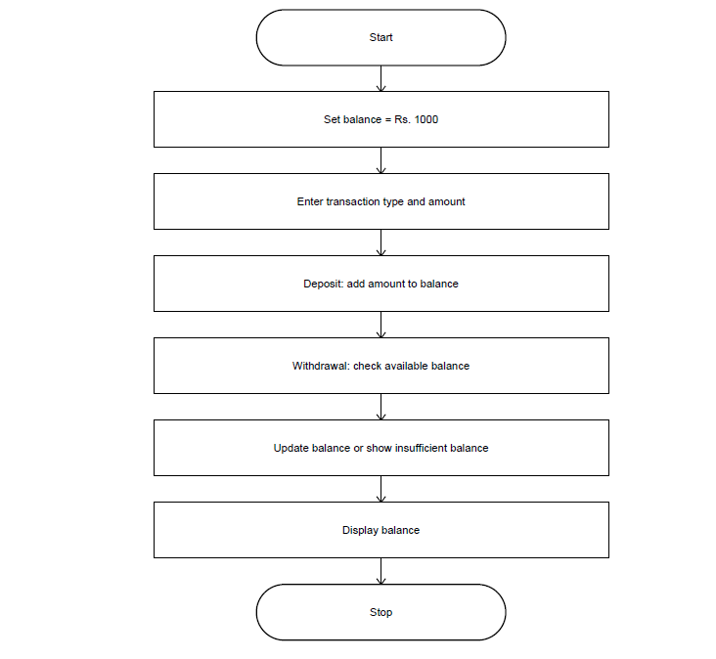

6. Pseudocode
START
balance = 1000
REPEAT
DISPLAY menu
INPUT choice
IF choice = 1: INPUT amount; IF amount > 0, add to balance
ELSE IF choice = 2: INPUT amount; withdraw if valid and affordable
ELSE IF choice = 3: PRINT balance
ELSE IF choice = 4: EXIT loop
ELSE: PRINT invalid choice
UNTIL choice = 4
STOP

7. Python Source Code
balance = 1000
while True:
print("1. Deposit")
print("2. Withdraw")
print("3. Check Balance")
print("4. Exit")
choice = int(input("Enter choice: "))
if choice == 1:
amount = float(input("Enter deposit amount: "))
if amount > 0:
balance += amount
print("Deposit successful")
else:
print("Invalid amount")
elif choice == 2:
amount = float(input("Enter withdrawal amount: "))
if 0 < amount <= balance:
balance -= amount
print("Withdrawal successful")
else:
print("Invalid amount or insufficient balance")
elif choice == 3:
print("Balance =", balance)
elif choice == 4:
break
else:
print("Invalid choice")
print("Thank you")

8. Test Cases and Outputs
Transactions
Expected final balance
Deposit Rs.500
Rs.1500
Withdraw Rs.200
Rs.800
Withdraw Rs.1500 from Rs.1000
Rejected; balance stays Rs.1000
Sample Output Screenshot (console-style panel)
1. Deposit
2. Withdraw
3. Check Balance
4. Exit
Enter choice: 1
Enter deposit amount: 500
Deposit successful
Enter choice: 3
Balance = 1500.0
Enter choice: 4
Thank you

Screenshot of output

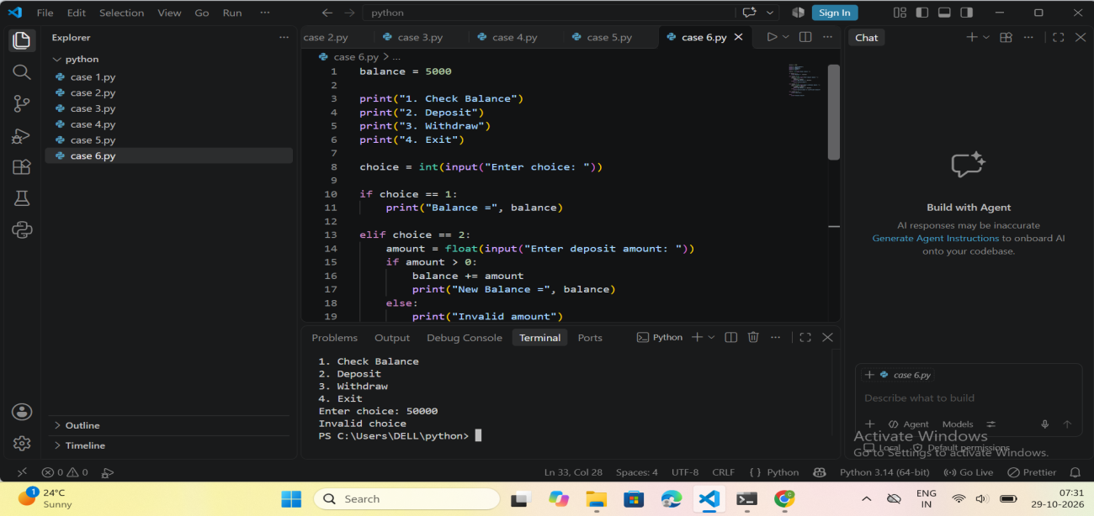

9. Conclusion
The program simulates basic ATM transactions using a while loop and conditional statements.

4. Warehouse Inventory Reconciliation

1. Problem Statement
Calculate closing stock using opening stock, incoming stock, and dispatched stock, and identify shortages.

2. Objectives
To maintain simple stock records and detect when dispatches exceed available stock.

3. Assumptions
All stock quantities must be non-negative.
Closing stock equals opening stock plus incoming stock minus dispatched stock.
A negative closing stock indicates a shortage.

4. Algorithm
1. Read the number of products.
2. For each product, read its name and stock quantities.
3. Validate that all quantities are non-negative.
4. Calculate closing stock.
5. Display closing stock and report a shortage if it is negative.

5. Flowchart

6. Pseudocode
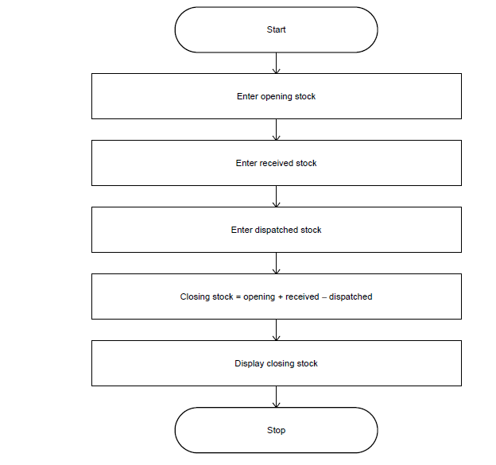
INPUT number of products
FOR each product
INPUT name, opening, incoming, dispatched
IF any quantity is negative
PRINT invalid stock details
ELSE
closing = opening + incoming - dispatched
PRINT closing
IF closing < 0: PRINT shortage
ELSE: PRINT stock available
END IF
END FOR
STOP

7. Python Source Code
n = int(input("Enter number of products: "))
for i in range(n):
print("\nProduct", i + 1)
name = input("Enter product name: ")
opening = int(input("Enter opening stock: "))
incoming = int(input("Enter incoming stock: "))
dispatched = int(input("Enter dispatched stock: "))
if opening < 0 or incoming < 0 or dispatched < 0:
print("Invalid stock details")
else:
closing = opening + incoming - dispatched
print("Product Name:", name)
print("Closing Stock:", closing)
if closing < 0:
print("Stock shortage detected!")
else:
print("Stock available")

8. Test Cases and Outputs
Opening, incoming, dispatched
Expected result
100, 50, 30
Closing stock = 120
40, 10, 60
Shortage of 10
20, 0, 10
Page 9
Closing stock = 10
Sample Output Screenshot (console-style panel)
Enter number of products: 1
Product 1
Enter product name: Pen
Enter opening stock: 100
Enter incoming stock: 50
Enter dispatched stock: 30
Product Name: Pen
Closing Stock: 120
Stock available

Screenshot of output

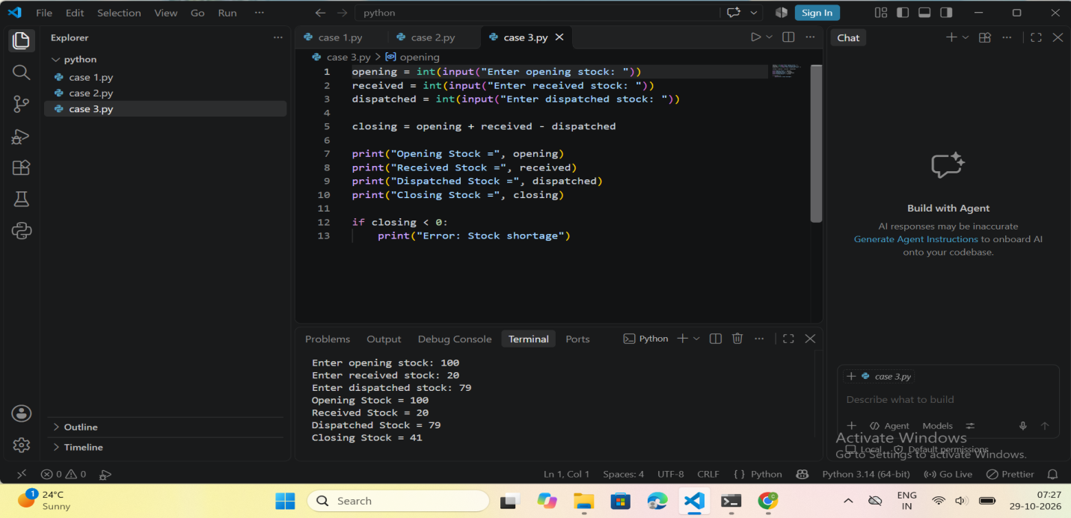

9. Conclusion
The program calculates stock balances and flags shortages using variables, loops, arithmetic, and conditions.

5. Smart Parking Fee Management

1. Problem Statement
Calculate a parking fee based on vehicle type and the number of parking hours.

2. Objectives
To calculate parking charges for cars and bikes and validate input.

3. Assumptions
Cars cost Rs.30 per hour.
Bikes cost Rs.15 per hour.
Any started/partial hour is not rounded up; the entered integer is treated as total chargeable hours.
Parking hours must be greater than zero.

4. Algorithm
1. Read vehicle type and parking hours.
2. Check that the hours are positive.
3. If the vehicle is a car, multiply hours by Rs.30.
4. If the vehicle is a bike, multiply hours by Rs.15.
5. For any other vehicle type, show an error.
6. Display the fee.

5. Flowchart 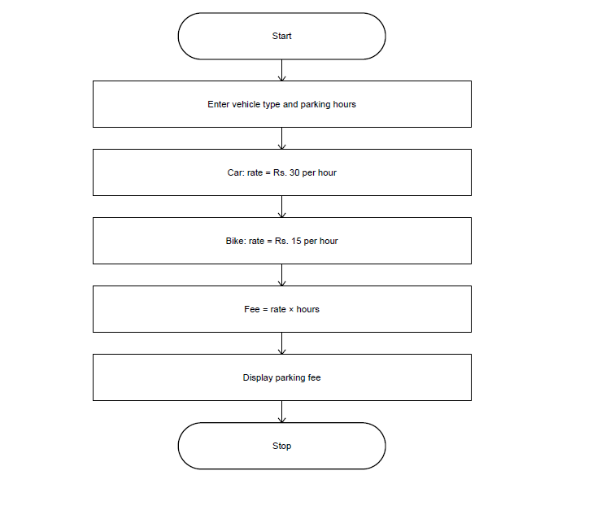

6. Pseudocode
START
INPUT vehicle, hours
IF hours <= 0
PRINT invalid parking hours
ELSE IF vehicle = car
fee = hours * 30
ELSE IF vehicle = bike
fee = hours * 15
ELSE
PRINT invalid vehicle type
END IF
PRINT fee when valid
STOP

7. Python Source Code
vehicle = input("Enter vehicle type (car/bike): ").lower()
hours = int(input("Enter parking hours: "))
if hours <= 0:
print("Invalid parking hours")
elif vehicle == "car":
print("Parking Fee =", hours * 30)
elif vehicle == "bike":
print("Parking Fee =", hours * 15)
else:
print("Invalid vehicle type")

8. Test Cases and Outputs
Vehicle, hours
Expected fee
car, 2
Rs.60
bike, 3
Rs.45
car, 0
Invalid parking hours
Sample Output Screenshot (console-style panel)
Enter vehicle type (car/bike): car
Enter parking hours: 2
Parking Fee = 60

Screenshot of output

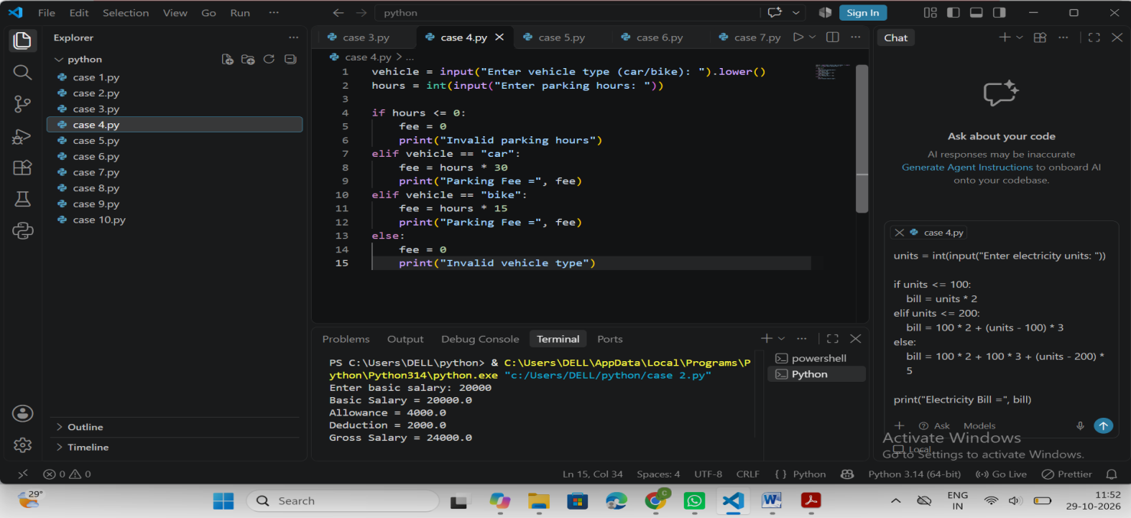

9. Conclusion
The program calculates parking fees based on vehicle category and hours using conditions and multiplication.

6. Password Policy Validation Engine

1. Problem Statement
Check whether a password satisfies basic length, digit, and uppercase-letter rules.

2. Objectives
To validate a sample password using string operations and conditions.

3. Assumptions
The password must contain at least 8 characters.
It must contain at least one digit.
It must contain at least one uppercase letter.
This is a basic demonstration and is not a complete security check.

4. Algorithm
1. Read a password.
2. Check whether its length is at least 8.
3. Check whether it contains a digit.
4. Check whether it contains an uppercase letter.
5. Display the first failed rule or report that the password is valid.

5. Flowchart 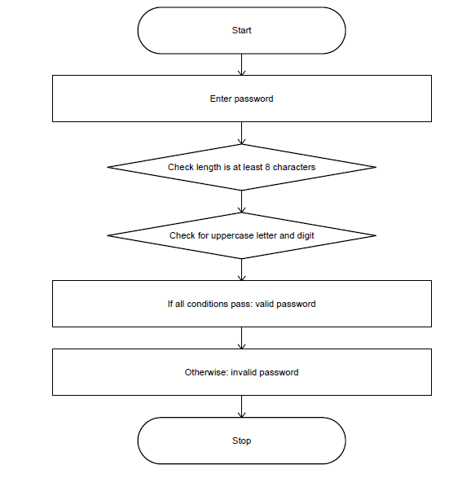

6. Pseudocode
START
INPUT password
IF length(password) < 8
PRINT minimum length error
ELSE IF password has no digit
PRINT number required
Page 12
ELSE IF password has no uppercase letter
PRINT uppercase letter required
ELSE
PRINT password is valid
END IF
STOP

7. Python Source Code
password = input("Enter password: ")
if len(password) < 8:
print("Password must contain at least 8 characters")
elif not any(ch.isdigit() for ch in password):
print("Password must contain a number")
elif not any(ch.isupper() for ch in password):
print("Password must contain an uppercase letter")
else:
print("Password is valid")

8. Test Cases and Outputs
Password
Expected result
Hello123
Valid
abc12
Minimum length error
helloworld
Number required
hello1234
Uppercase letter required
Sample Output
Enter password: Hello123
Password is valid

Screenshot of output
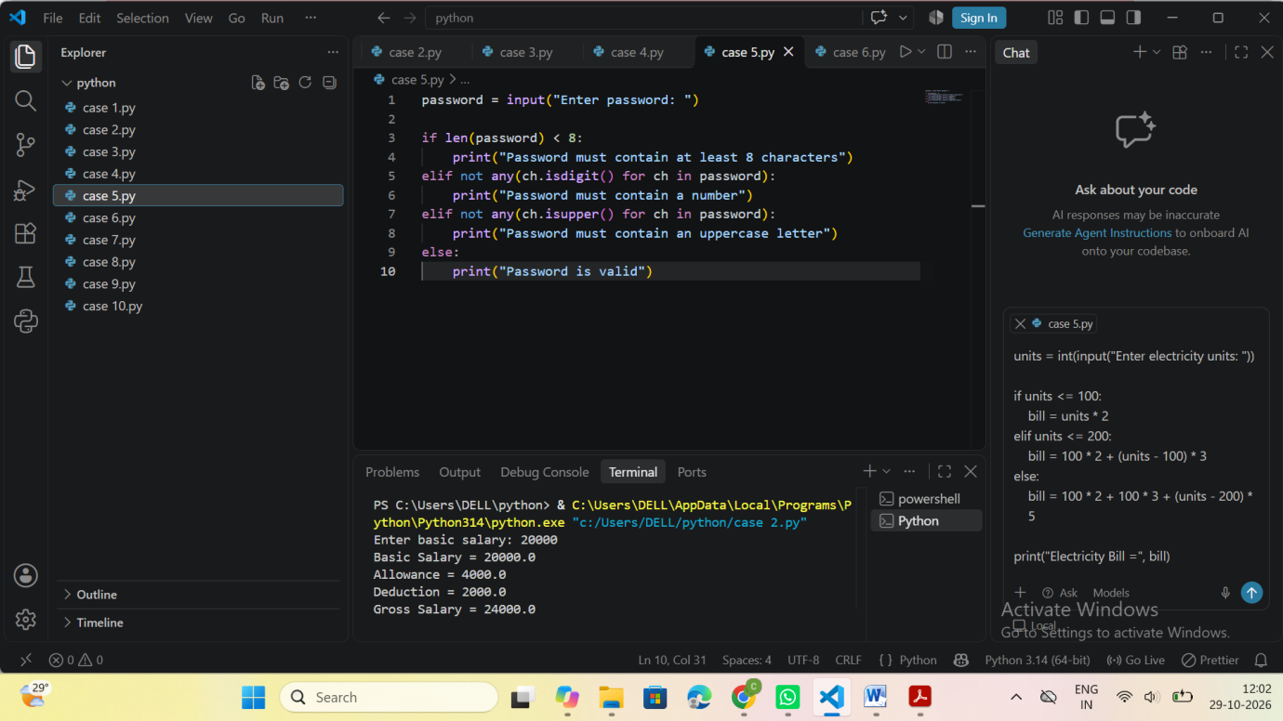

9. Conclusion
The program uses len(), string character checks, and if-elif-else statements to validate a password.

7. String-Based Examination Answer Evaluation
1. Problem Statement
Compare a student's answers with an answer key and calculate correct and wrong answers.

2. Objectives
To practise strings, loops, indexing, and counting correct answers.

3. Assumptions
The answer key is ABCDE.
The student must enter exactly five answers.
Each correct answer earns one mark; there is no negative marking.
Answers are compared without considering letter case.

4. Algorithm
1. Store the answer key.
2. Read the student's answers and convert them to uppercase.
3. Check that exactly five answers are entered.
4. Compare each answer with the corresponding key character.
5. Count correct and wrong answers and display the result.

5. Flowchart

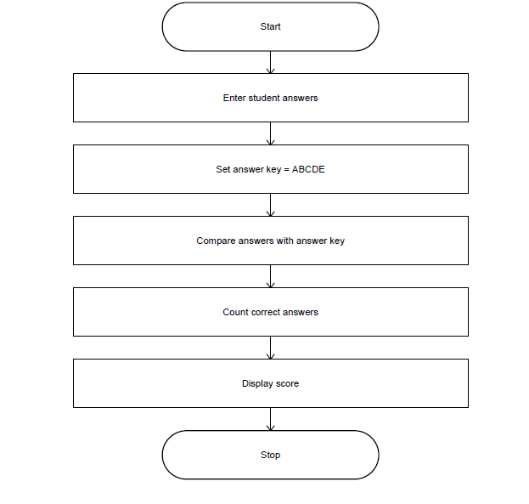

6. Pseudocode
START
key = ABCDE
INPUT answer
CONVERT answer to uppercase
IF length(answer) != 5
PRINT enter exactly 5 answers
ELSE
score = 0
FOR each index from 0 to 4
IF answer[index] = key[index]: score = score + 1
END FOR
PRINT correct = score
PRINT wrong = 5 - score
END IF
STOP

7. Python Source Code
key = "ABCDE"
answer = input("Enter 5 answers (A-E): ").upper()
if len(answer) != len(key):
print("Enter exactly 5 answers")
else:
score = 0
for i in range(len(key)):
if answer[i] == key[i]:
score += 1
print("Correct Answers =", score)
print("Wrong Answers =", len(key) - score)

8. Test Cases and Outputs
Answers
Expected result
ABCDE
5 correct, 0 wrong
ABCDA
4 correct, 1 wrong
AAAAA
1 correct, 4 wrong
ABC
Length error
Sample Output Screenshot (console-style panel)
Enter 5 answers (A-E): ABCDA
Correct Answers = 4
Wrong Answers = 1

c
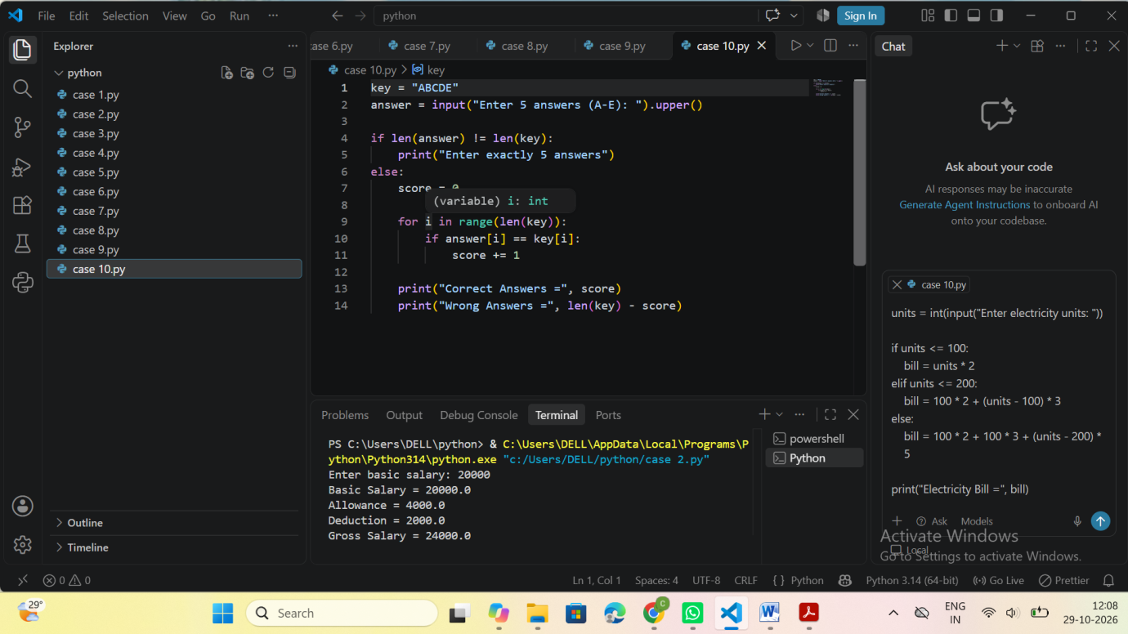

9. Conclusion
The program compares strings character by character and counts correct and incorrect answers.

8. ATM Menu-Driven Banking Simulation

1. Problem Statement
Create a simple ATM menu that lets a user check balance, deposit money, withdraw money, or exit.

2. Objectives
To practise menu-driven programming with if-elif-else statements.

3. Assumptions
The opening balance is Rs.5,000.
Only one menu action is performed before the program ends.
Deposits and withdrawals must be positive.
Withdrawals cannot exceed the available balance.

4. Algorithm
1. Set the opening balance to Rs.5,000.
2. Display the menu and read a choice.
3. Perform the selected operation.
4. Validate deposit or withdrawal amounts.
5. Display the updated balance where relevant.
6. Exit after the selected action.

5. Flowchart

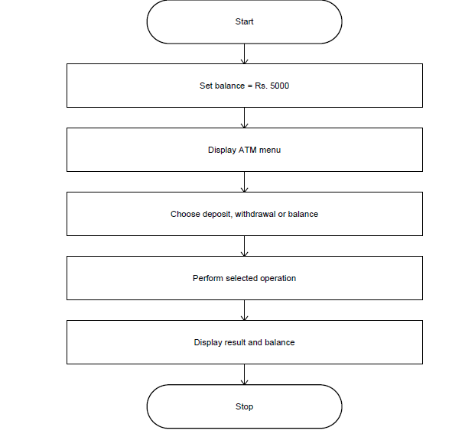

6. Pseudocode
START
balance = 5000
DISPLAY menu
INPUT choice
IF choice = 1: PRINT balance
ELSE IF choice = 2: INPUT amount; add if positive
ELSE IF choice = 3: INPUT amount; subtract if valid and affordable
ELSE IF choice = 4: PRINT thank you
ELSE: PRINT invalid choice
STOP

7. Python Source Code
balance = 5000
print("1. Check Balance")
print("2. Deposit")
print("3. Withdraw")
print("4. Exit")
choice = int(input("Enter choice: "))
if choice == 1:
print("Balance =", balance)
elif choice == 2:
amount = float(input("Enter deposit amount: "))
if amount > 0:
balance += amount
print("New Balance =", balance)
else:
print("Invalid amount")
elif choice == 3:
amount = float(input("Enter withdrawal amount: "))
if 0 < amount <= balance:
balance -= amount
print("New Balance =", balance)
else:
print("Invalid amount or insufficient balance")
elif choice == 4:
print("Thank you")
else:
print("Invalid choice")

8. Test Cases and Outputs
Choice and amount
Expected result
1
Balance = Rs.5000
2, deposit 500
New balance = Rs.5500
3, withdraw 6000
Rejected
4
Thank you
Sample Output Screenshot (console-style panel)
1. Check Balance
2. Deposit
3. Withdraw
4. Exit
Enter choice: 2
Enter deposit amount: 500
New Balance = 5500.0

9. Conclusion
The program performs one banking operation using a menu, conditions, and balance calculations.

9. Food Waste Monitoring System

1. Problem Statement

Calculate leftover meals and the percentage of prepared meals that were wasted.

2. Objectives
To measure food waste and calculate meals consumed using basic arithmetic.

3. Assumptions
The number of meals prepared must be greater than zero.
Leftover meals must be between zero and the number prepared.
All leftover meals are treated as wasted meals.

4. Algorithm
1. Read meals prepared and leftover meals.
2. Validate the values.
3. Calculate waste percentage.
4. Calculate meals consumed.
5. Display waste and consumption details.

5. Flowchart
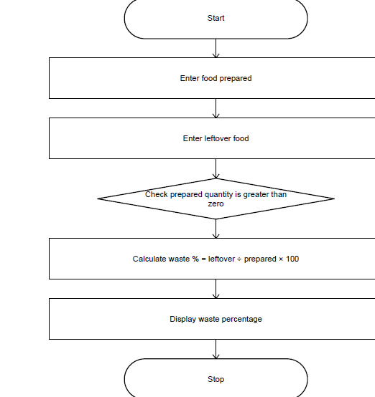

6. Pseudocode
START
INPUT prepared, leftover
IF prepared <= 0 OR leftover < 0 OR leftover > prepared
PRINT invalid meal details
ELSE
percentage = leftover / prepared * 100
consumed = prepared - leftover
PRINT leftover, percentage, consumed
END IF
STOP

7. Python Source Code
prepared = int(input("Enter meals prepared: "))
leftover = int(input("Enter leftover meals: "))
if prepared <= 0 or leftover < 0 or leftover > prepared:
print("Invalid meal details")
else:
percentage = leftover / prepared * 100
consumed = prepared - leftover
print("Meals Wasted =", leftover)
print("Waste Percentage =", percentage, "%")
print("Meals Consumed =", consumed)

8. Test Cases and Outputs
Prepared, leftover
Expected result
100, 20
20% wasted; 80 consumed
50, 0
0% wasted; 50 consumed
30, 35
Invalid meal details
Sample Output Screenshot (console-style panel)
Enter meals prepared: 100
Enter leftover meals: 20
Meals Wasted = 20
Waste Percentage = 20.0 %
Meals Consumed = 80
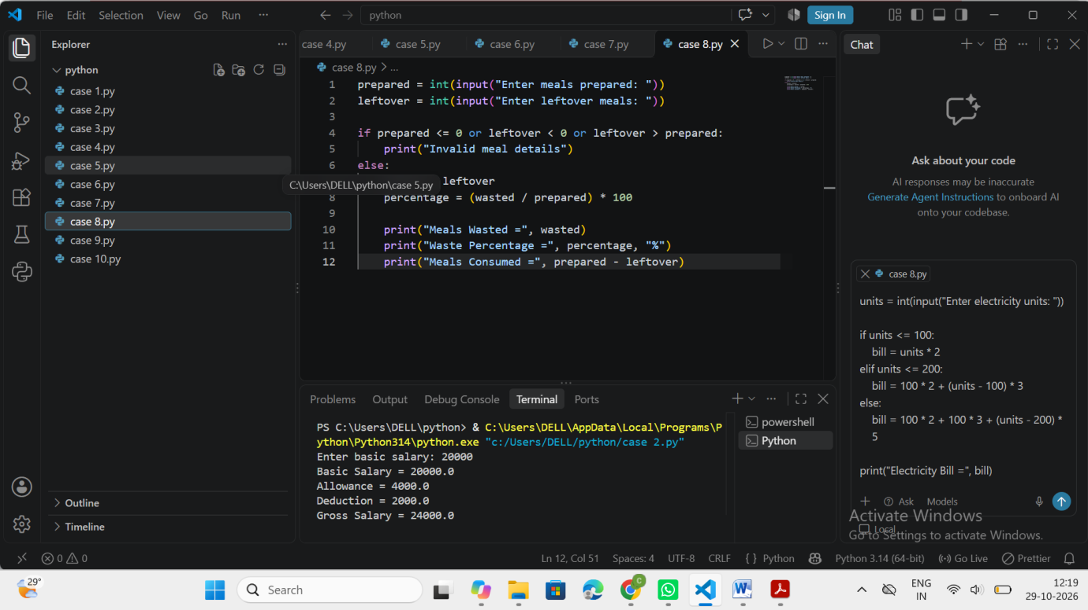

9. Conclusion
The program calculates food waste percentage and meals consumed using arithmetic and input validation.

10. Library Borrowing and Fine Reconciliation

1. Problem Statement
Calculate a library fine based on the number of days a book is kept beyond the allowed borrowing period.

2. Objectives
To use tuples and conditional statements to store borrowing details and calculate a fine.

3. Assumptions
The allowed borrowing period is 7 days.
The fine is Rs.5 for each day beyond 7 days.
No fine is charged when the book is returned within 7 days.

4. Algorithm
1. Read borrower name, book name, and days kept.
2. Store the details in a tuple.
3. If days kept exceed 7, calculate the fine.
4. Otherwise, set the fine to zero.
Page 19
5. Display borrower, book, days, and fine.

5. Flowchart
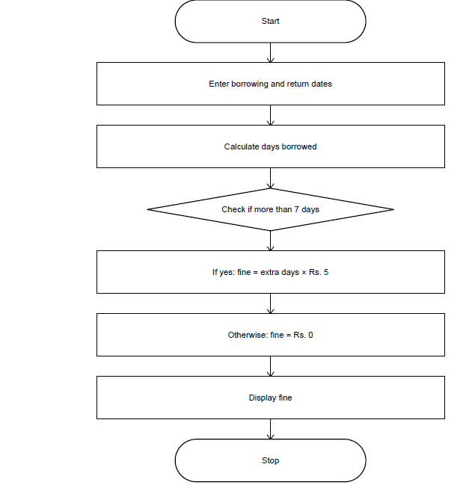

6. Pseudocode
START
INPUT borrower, book, days
record = (borrower, book, days)
IF days < 0
PRINT invalid days
ELSE IF days > 7
fine = (days - 7) * 5
ELSE
fine = 0
END IF
PRINT record and fine
STOP

7. Python Source Code
borrower = input("Enter student name: ")
book = input("Enter book name: ")
days = int(input("Enter days kept: "))
if days < 0:
print("Invalid number of days")
else:
record = (borrower, book, days)
if days > 7:
fine = (days - 7) * 5
else:
fine = 0
print("Borrower =", record[0])
print("Book =", record[1])
print("Days Kept =", record[2])
print("Fine = Rs.", fine)

8. Test Cases and Outputs
Days kept
Page 20
Expected fine
5
Rs.0
7
Rs.0
10
Rs.15
-1
Invalid number of days
Sample Output Screenshot (console-style panel)
Enter student name: Ravi
Enter book name: Python
Enter days kept: 10
Borrower = Ravi
Book = Python
Days Kept = 10
Fine = Rs. 15

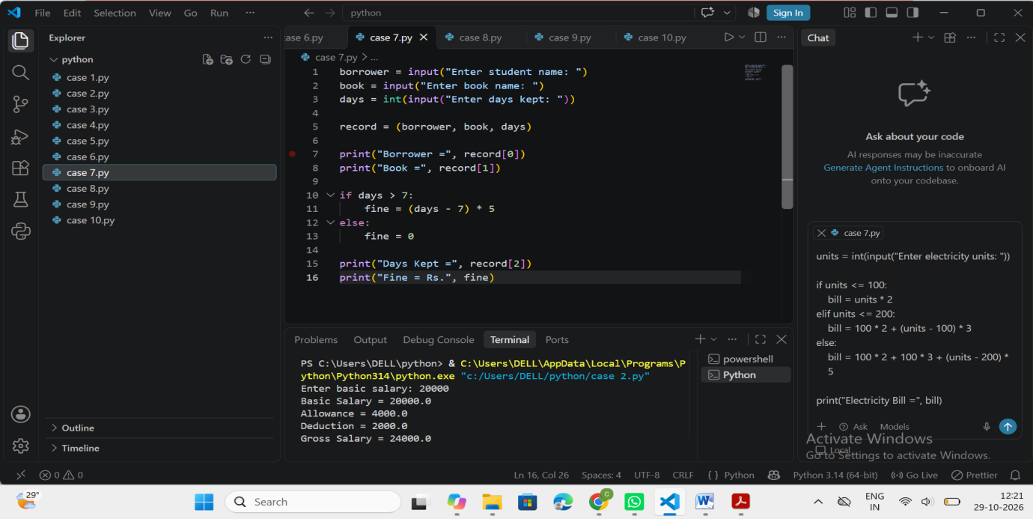

9. Conclusion
The program stores borrowing details in a tuple and calculates overdue fines using conditional statements.

